**Flooding Video:** <https://www.youtube.com/watch?v=eziOAdaun_s>

**Link State Routing Video:** <https://www.youtube.com/watch?v=2_0AwfQWKUk>

**1. Flooding**

* Nodes know only the cost to their neighbors (until they receive forwarded information from other nodes)
* Nodes can only send messages (through server) to its neighbors
* Each node will send out routing information to each of its neighbors
  + Basically a forwarding table with the cost to get to that neighbor (see pic below)
  + Once that neighbor receives the source’s routing information, it will forward it to all its neighbors nodes (except the ones where it was sent from)

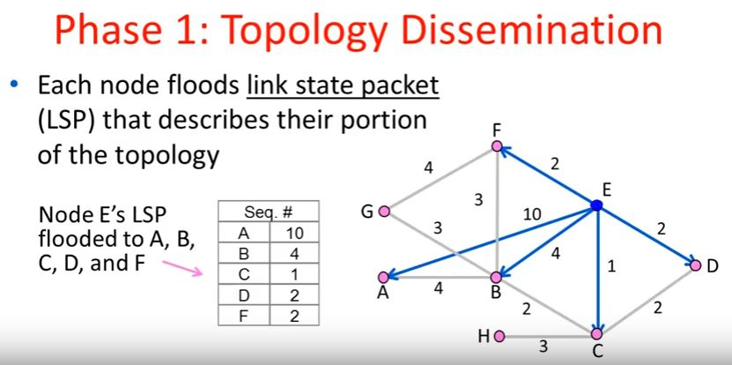

* Remember message so that it only gets flooded once (discard copies of flooded msg)
  + Use source and sequence number
  + (e.g. n1 flooded a message with sequence number 1, so if you receive another message from another node with source n1 and sequence number 1 or lower, it can be discarded)
  + Update sequence number to know which flooded message is the latest one
* As you flood nodes with routing information, add it to a Graph to get a picture of the whole topology of the network

**2. Create Routing Table (Using Dijkstra’s Algorithm)**

* As each node gets full topology of the network, run Dijkstra’s on the graph every “Update Interval”
* Add this information to our routing table
* Dumptable only displays routing information to paths that can actually be reached